**PYTHON – WORKSHEET 1**

1. Which of the following operators is used to calculate remainder in a division?

A) # B) &

C) % D) $

Ans- Option-C (%)

2. In python 2//3 is equal to?

A) 0.666 B) 0

C) 1 D) 0.67

Ans- Option- B (0)

3. In python, 6<<2 is equal to?

A) 36 B) 10

C) 24 D) 45

Ans- Option- C (24)

4. In python, 6&2 will give which of the following as output?

A) 2 B) True

C) False D) 0

Ans- Option- A (2)

5. In python, 6|2 will give which of the following as output?

A) 2 B) 4

C) 0 D) 6

Ans- Option-D (6)

6. What does the finally keyword denotes in python?

A) It is used to mark the end of the code

B) It encloses the lines of code which will be executed if any error occurs while executing the lines of code in the try block.

C) the finally block will be executed no matter if the try block raises an error or not.

D) None of the above

Ans- Option-A (It is used to mark the end of the code)

7. What does raise keyword is used for in python?

A) It is used to raise an exception. B) It is used to define lambda function

C) it's not a keyword in python. D) None of the above

Ans- Option-A (It is used to raise an exception)

8. Which of the following is a common use case of yield keyword in python?

A) in defining an iterator B) while defining a lambda function

C) in defining a generator D) in for loop.

Ans- Option-C (in defining a generator)

9. Which of the following are the valid variable names?

A) _abc B) 1abc

C) abc2 D) None of the above

Ans- Option-A & C (_abc & abc2)

10. Which of the following are the keywords in python?

A) yield B) raise

C) look-in D) all of the above

Ans- Option- A & B (yield & raise)

11. Write a python program to find the factorial of a number.

Ans- # factorial of given number

def factorial(n):

# single line to find factorial

return 1 if (n==1 or n==0) else n * factorial(n - 1)

# Driver Code

num = 3

print("Factorial of",num,"is",factorial(num))

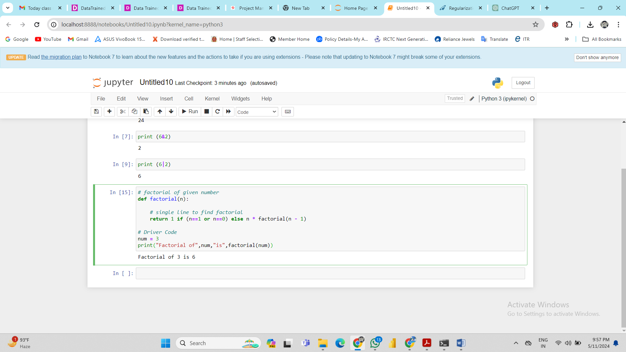

12. Write a python program to find whether a number is prime or composite.

Ans- Input=int(input("Enter a number to check: "))

count=0

for Number in range(1,Input+1):

Remainder=Input%Number

if (Remainder==0):

count=count+1

if (count==1):

print("The number is neither prime nor composite.")

if(count==2):

print("The number is a prime number.")

elif(count>=3):

print("The number is a composite number.")

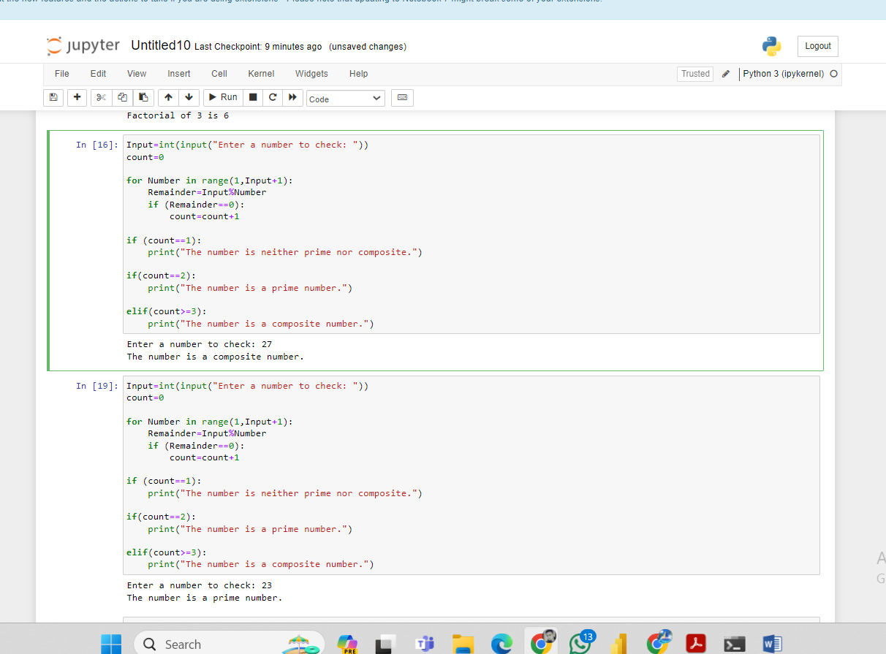

13. Write a python program to check whether a given string is palindrome or not.

14. Write a Python program to get the third side of right-angled triangle from two given sides.

Ans- # Define a function 'pythagoras' that calculates the missing side of a right-angled triangle.

def pythagoras(opposite_side, adjacent_side, hypotenuse):

# Check if the opposite side is marked as unknown.

if opposite_side == str("x"):

return ("Opposite = " + str(((hypotenuse**2) - (adjacent_side**2))**0.5))

# Check if the adjacent side is marked as unknown.

elif adjacent_side == str("x"):

return ("Adjacent = " + str(((hypotenuse**2) - (opposite_side**2))**0.5))

# Check if the hypotenuse is marked as unknown.

elif hypotenuse == str("x"):

return ("Hypotenuse = " + str(((opposite_side**2) + (adjacent_side**2))**0.5))

else:

return "You know the answer!" # Return this message if all sides are known.

# Test the function with different inputs and print the results.

print(pythagoras(8, 5, 'x'))

print(pythagoras(8, 'x', 6))

print(pythagoras('x', 5, 6))

print(pythagoras(8, 5, 6))

15. Write a python program to print the frequency of each of the characters present in a given string.

Ans- # Python3 code to demonstrate

# each occurrence frequency using

# naive method

# initializing string

test_str = "DelhitoDelhi"

# using naive method to get count

# of each element in string

all_freq = {}

for i in test_str:

if i in all_freq:

all_freq[i] += 1

else:

all_freq[i] = 1

# printing result

print("Count of all characters in DelhitoDelhi is :\n "

+ str(all_freq))